Zudio Sales Dataset

Data Analysis + Retail Stock Predictive model

- Project Overview
This project focuses on analyzing Zudio retail sales data to understand store performance, customer buying patterns, and category-wise demand across different locations. The analysis involved extensive data cleaning, transformation, SQL-based querying, and dashboard creation.

- Dataset Summary
The dataset contained 7,899 sales records and 28 columns, including:
- Store details (city, state, area size, staff count, store type)
- Product information (category, clothing type, price, quantity)
- Customer details
- Sales & profit values
- Monthly/seasonal trends
- Operational data such as parking, security features, and opening date
- Exploratory Data Analysis
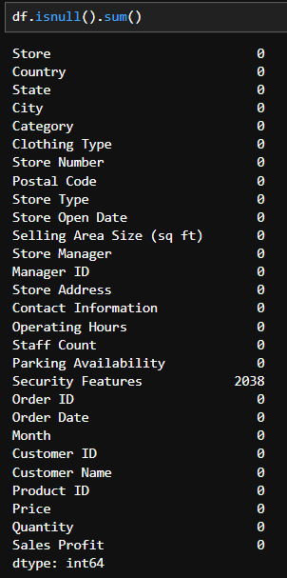
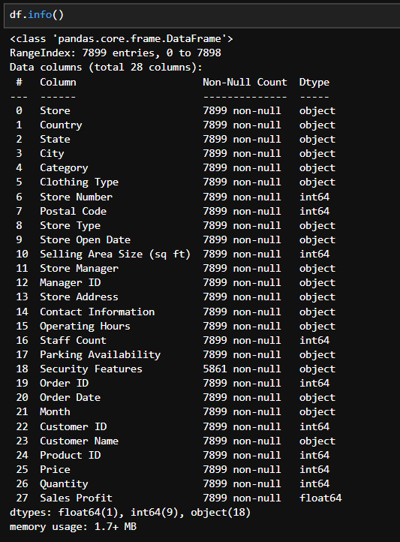
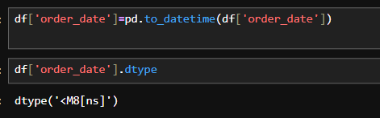
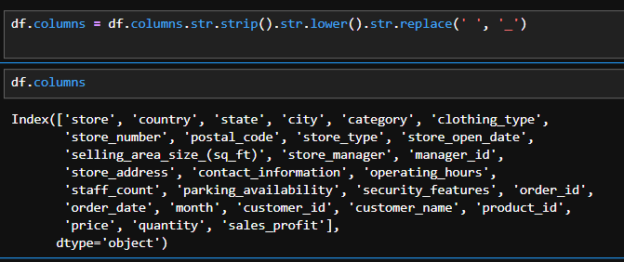
• Certain cities showed consistently high revenue
• Women’s clothing and T-shirts/Jeans sold the most
• Sales increased during festive months
• Store size and staff count showed mild correlation with quantity sold

- Data Analysis using SQL
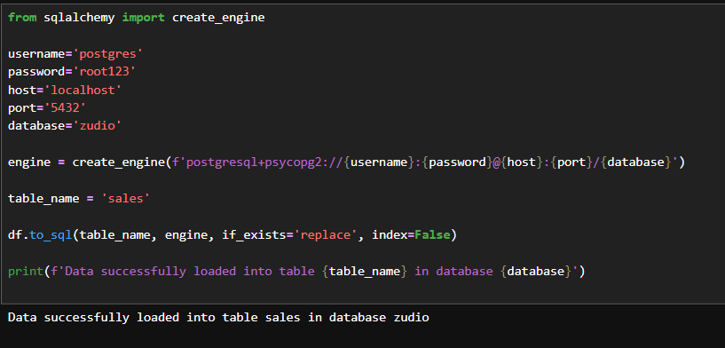
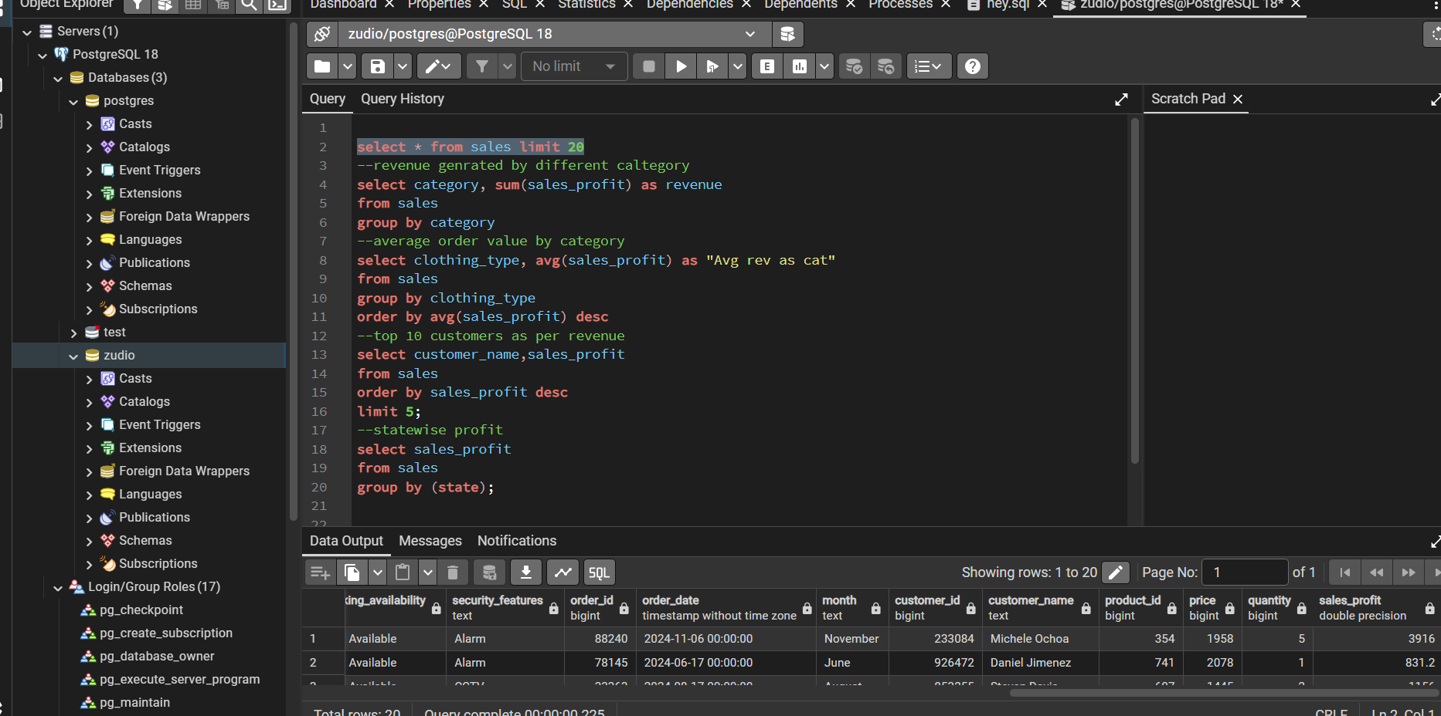

- Data Visualisation
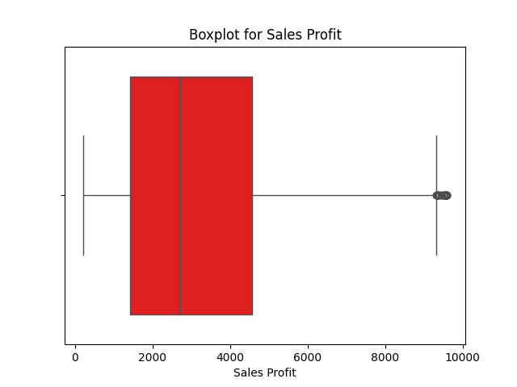
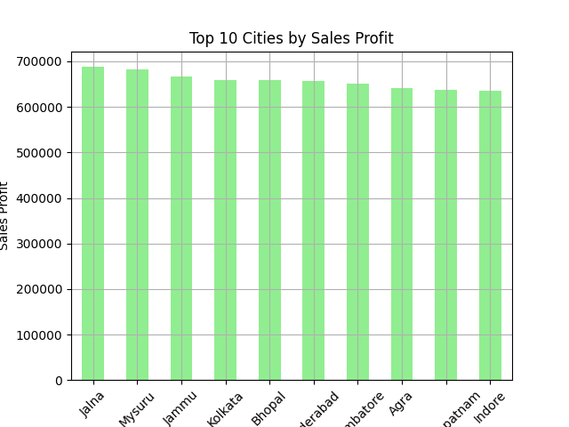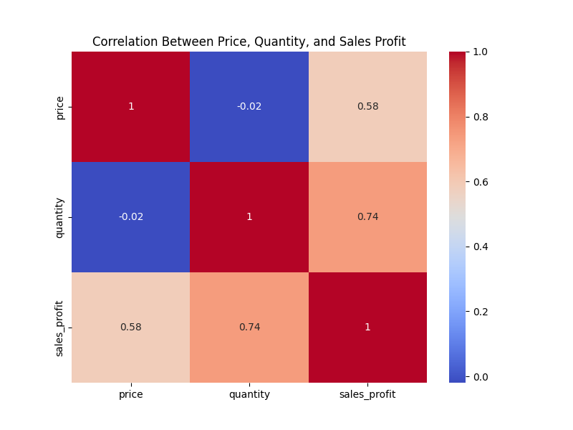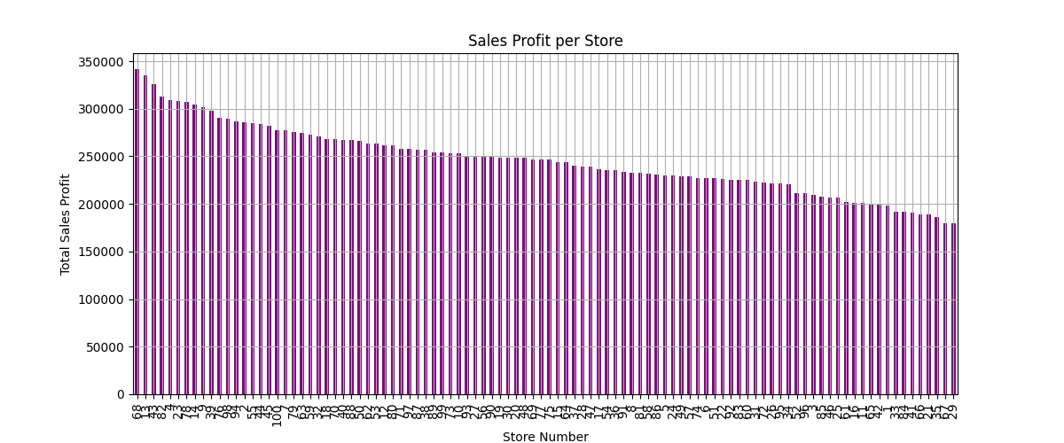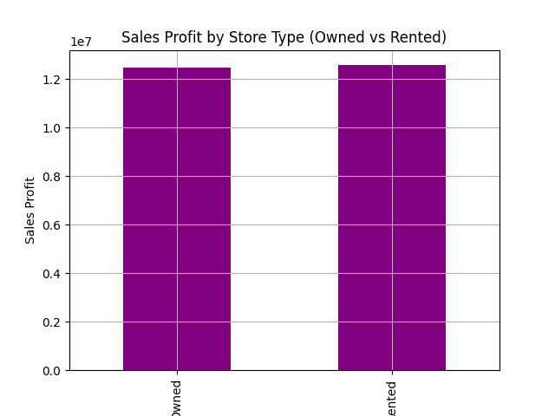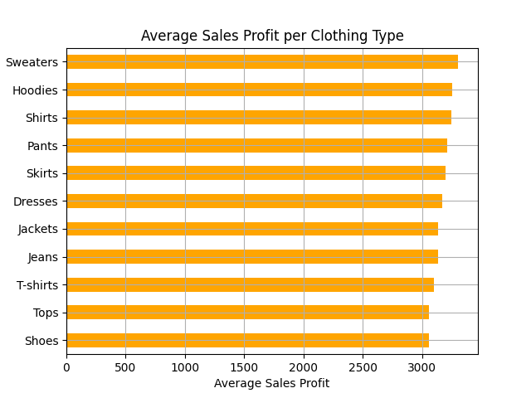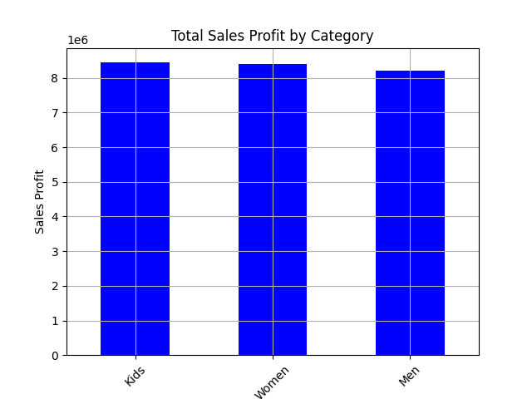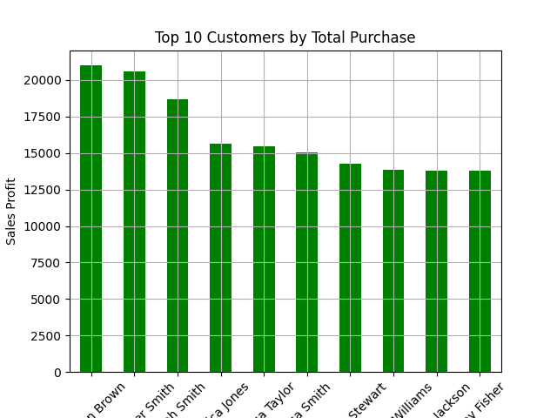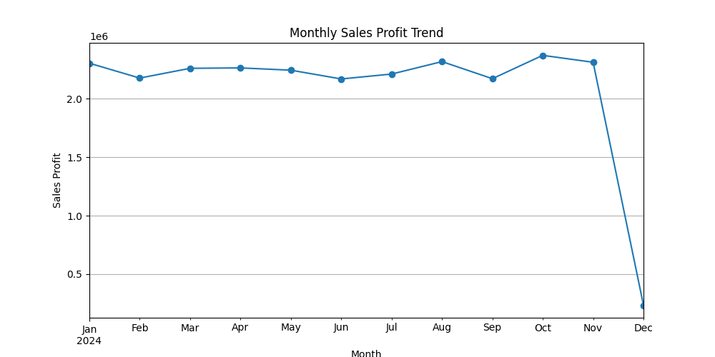

- Power BI (Dashboard)
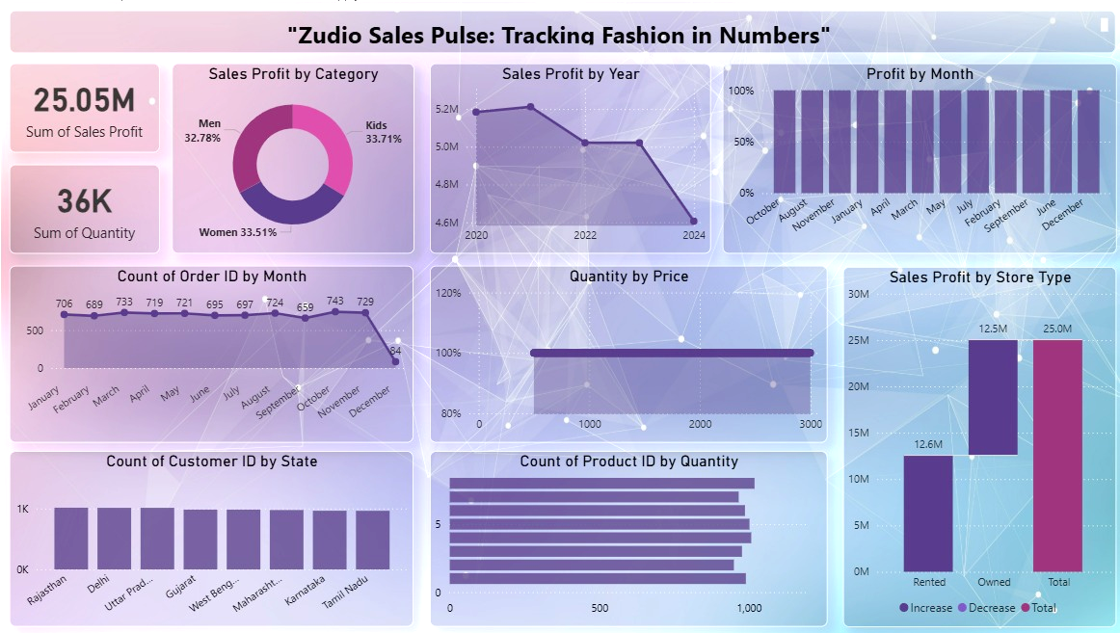

- Predictive Model
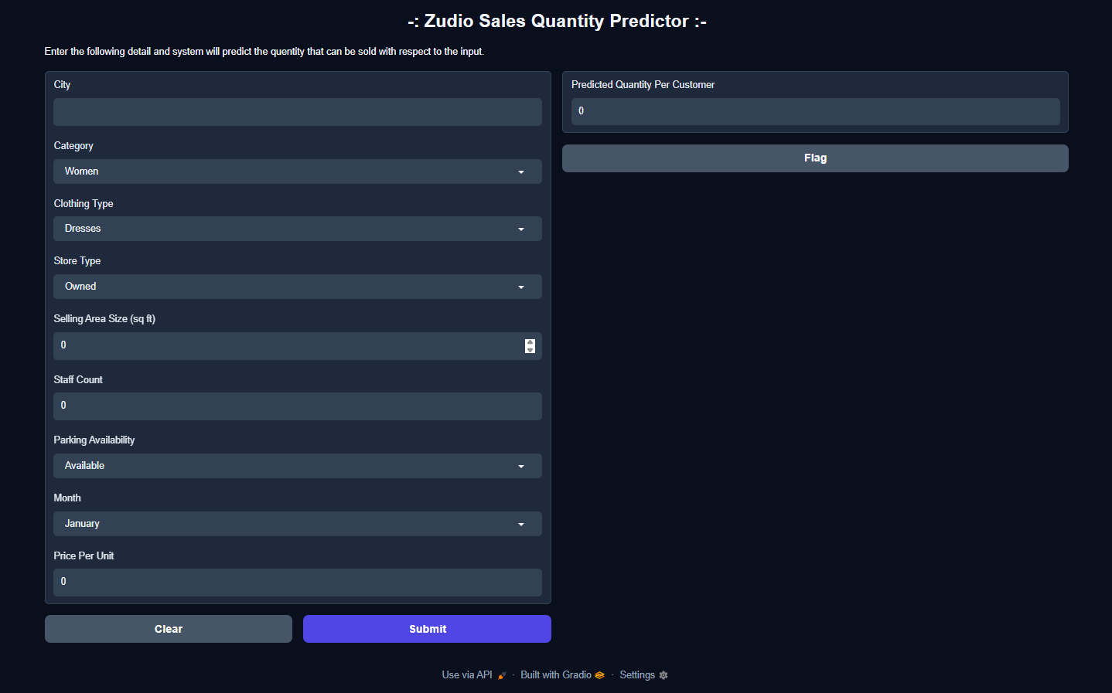
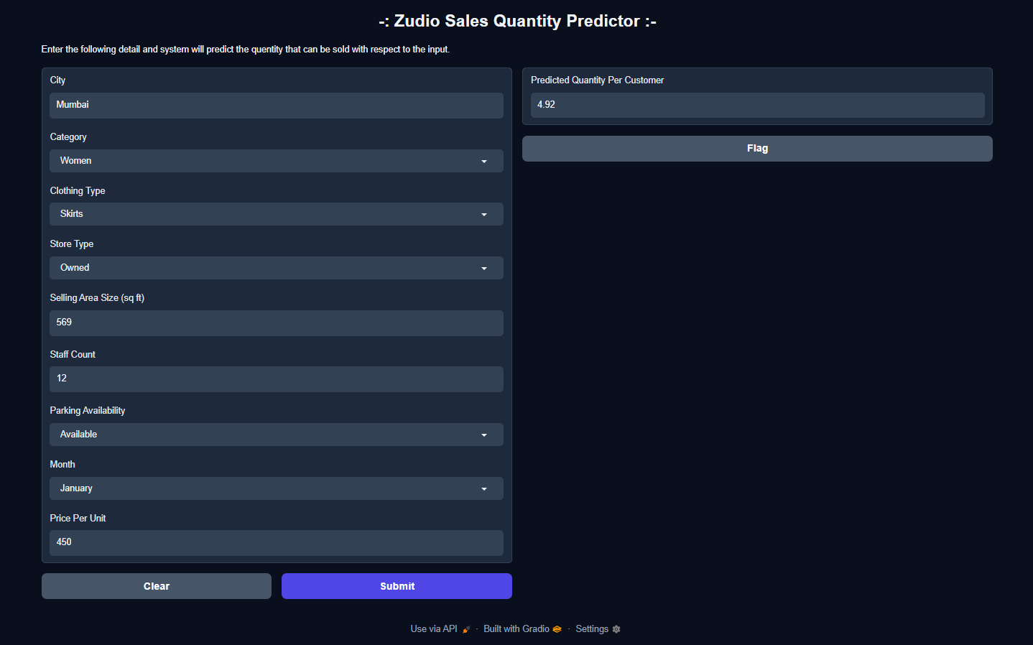
Methods used:
- Feature preprocessing (Label Encoding, OneHotEncoding, imputation)
- Train-test split
- Model experimentation with:
  - Random Forest Regressor
  - Gradient Boosting (HistGradientBoostingRegressor)
  - Linear Regression
